Room B
BQ1 Gall Stone Ileus
Stem: A 76-year-old demented woman presents to the emergency department from her nursing facility with 4 days of intermittent abdominal pain, confusion, food intolerance, emesis and diminished urinary output.
Past medical history includes Alzheimer’s dementia, COPD, CAD, HTN, cholelithiasis, HLD.
Past surgical history includes total abdominal hysterectomy.
Examination: HR 110bpm, BP 106/43mmHg, 92% sats on room air, 36.6C. Abdomen is distended and tympanic however soft, with generalized tenderness without involuntary guarding or signs of peritonitis.

Pertinent labs: WBC of 12.4, LA 2.4, NA 130, Chloride 92. LFTs, lipase and amylase are within normal limits.

What studies would you order?

- Abdominal xray
- CT scan

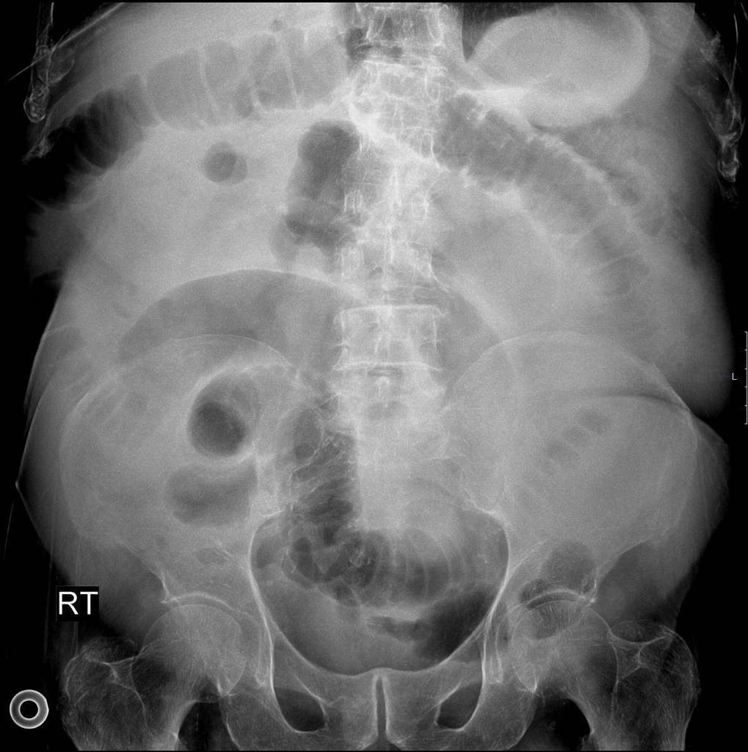

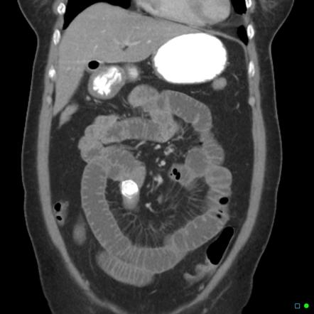

What is your differential diagnosis?
- Small bowel obstruction
- Gallstone ileus
- Mesenteric ischemia
- Intestinal perforation
- Malignancy
What would you like to do now?
- NGT decompression
- IV access
- Resuscitation.

To examiner: Resident should be able to recognize gallstone ileus on imaging

- OR for ex-lap
  - Inspect/palpate entire midgut.
  - Longitudinal enterotomy, stone extraction and closure in H-M fashion

How do you manage cholecystoenteric fistula?
leave it alone in old, frail and sick patients.

Scenario 1: Same patient, however, you are unable to milk the stone out proximally.
Perform a segmental small bowel resection.
Scenario 2: Same patient successfully treated with enterotomy with stone retrieval and primary closure of the small bowel. In the coming days becomes increasingly tachycardic, febrile, and hypotensive.

What is you diagnosis? How would you manage?
Enteric leak
- IVF resuscitation.
- Empiric abx.
- If stable CT
- Versus Immediate return to OR

Scenario3: Gallstones ileus identified in a 60-year-old farmer with history of HTN and HLD, otherwise physically active and relatively healthy.
What would you do with the gallbladder and cholecystoenteric fistula in this setting?

- Explores gallbladder and identifies whether there is residual stones.
- If the patient is stable and can undergo long procedure would be acceptable to perform cholecystectomy and closure of cholecystoenteric fistula at time of surgery, otherwise perform as staged procedure.
- At time of cholecystectomy, performs cholangiogram to ensure CBD exploration does not need to be performed.

Describe how to repair the duodenum?
Debride edges if needed, assess posterior ampulla, primary repair transversely to avoid stricture. Protection of repair: buttress with omental fat/falciform, serosal flap. JP drain.

Pitfalls:
- Not recognizing high risk of fistula take down in acute setting.
- Not performing cholangiogram at time of surgery to rule out need for CBD exploration.
- Not knowing rule of fistula staged take down or at time of surgery IF appropriate.
References:
- https://www.facs.org/for-medical-professionals/news-publications/journals/case-reviews/issues/v3n8/jacobucci-gallstone-ileus/

BQ2 UGI GI Bleed – Portal hypertension with Gastroesophageal Varices
Stem: You are called to the ER to evaluate a 40 year old female with a past medical history of alcoholic cirrhosis who presents with hematemesis and hematochezia associated with abdominal pain.
No other significant past medical or surgical history.
Exam:
- VS: T 98 F, HR 110, BP 110/75, RR 20, O2 saturation 90% on room air.
- Pale
- Alert and oriented X3, and has palpable distal pulses.
Labs: WBC 5, Hgb 9, Plt 80, Na 130, K 3.4, BUN 25, Cr 1.3, Gluc 200, Alb 3, T. bili 4.2, Alk phos 120, AST 55, ALT 27, INR 1.4. MELD score is 23.
What is your differential diagnosis?
- Bleeding esophageal or gastric varices
- Peptic ulcer
- Mallory-Weiss

What would you like to do now?
- ABCs
  - Intubate if patient cannot protect airway.
  - IV access with large bore IVs
  - Fluid resuscitation / blood
  - Foley
  - Arterial line

- Initiate meds to lower portal pressure (below 12 mm Hg) with splanchnic vasoconstrictors.
  - Octreotide bolus and drip (or Vasopressin, administered with nitroglycerin), continue for 3-5 days.
3. Prophylactic antibiotics PRIOR to EGD, s/a Ceftriaxone.
4. EGD if patient is stable.
a. Perform banding (preferred) or sclerotherapy of esophageal varices.

Describe how to perform EGD?

Procedural sedation

Place in left lateral decubitus position.

Insert scope into mouth under direct visualization.

Pass the scope past the cricoarytenoid cartilage into the esophagus.

Ensuring direct visualization, pass the scope through the esophagus with continuous insufflation in order to visualize the entire esophagus.

Visualize the gastroesophageal junction and pass into the stomach.

Scenario: Same patient but with a heart rate of 120 and hypotensive, and they remained hypotensive despite the initiation of fluid and blood products’ resuscitation. Now what?
- ABCs : Intubate to protect airway.
- Balloon tamponade with Sengstaken-Blakemore tube or Minnesota tube to temporize patient

How do you do it? Describe?
  - Check balloons for leaks.
  - Deflate
  - Insert the tube via mouth.
  - Advance to 50 cm
  - Confirm position of gastric balloon in stomach with X-ray.
  - Inflate the gastric balloon in 50mL increments. Go up to 250 -300ml for SBT or 450-500ml for Minnesota tube.
  - Once inflated, pull the balloon back so it is against gastric fundus.
  - Take note of measurement at lips.
  - Secure with traction and rope pulley system using bag of fluid.
  - Must remove after 24-36 hours.

Note: Inflation of esophageal balloon usually is not required (if required inflate to 40mmHg).
Use only if there is continued bleeding despite adequate inflation of the gastric balloon.
Resident should not use the esophageal balloon on its own.

The patient has refractory bleeding. What would you do next?
1. Repeat EGD and attempts to control bleeding endoscopically. Otherwise, TIPS or surgery.
a. Childs C → TIPS.
b. Childs A/B → Surgical shunt

Describe TIPS

TIPS: needle introduced via right internal jugular vein → pass from hepatic vein to portal vein → tract is dilated with a balloon → stent placed in the tract. Done under fluoro.

Describe one emergency surgery to control bleeding:
- Portacaval shunt: one method joins portal vein to IVC in end to side manner, disrupting portal vein flow to liver. OR, connect portal vein and IVC in a side to side manner, which allows partial portal venous flow to liver.
Note : Rarely done anymore, as there is high incidence of hepatic encephalopathy and decreased liver function.
- Mesocaval shunt: use 8-10 mm PTFE graft to connect SMV to IVC. Easier to perform and can be ligated during future liver transplant.
- Selective distal splenorenal shunt (Warren shunt: used most. Divide gastroesophageal collaterals. Venous drainage of stomach continues through short gastrosplenic veins. End to side splenic to renal vein anastomosis.
- Suiguira procedure: extensive devascularization of stomach and distal esophagus. Also includes transection of esophagus, splenectomy, truncal vagotomy, and pyloroplasty.
e. Esophageal transection: Vagus nerves are dissected away from GE junction → anterior gastrotomy, EEA stapler placed in GE junction through gastrotomy → silk suture used to tie esophagus to stapler in open position → stapler fired →confirm 2 doughnuts → close gastrotomy.
If The patient has gastric varices. How does management differ?
- Octreotide or Vasopressin
- EGD.
- TIPS or surgery
Patient is now following up as an outpatient. What is your surveillance strategy and outpatient management?
1. Initiation of non-selective Beta Blocker (propranolol)
2. EGD with banding/sclerotherapy q2-8 weeks until varices are obliterated.
3. Consider elective TIPS

When to refer for transplant evaluation?
- MELD > 14
- No EtOH usage
Pitfalls:
- Work up including EGD
- Not knowing how to use tube.
- Not using Vasopressin or Octreotide.
- Not giving antibiotics.
- Not knowing to repeat EGD.
- Not knowing when to do TIPS versus surgery.
References:
Biecker E. Portal hypertension and gastrointestinal bleeding: diagnosis, prevention and management. World J Gastroenterol. 2013;19(31):5035-5050. doi:10.3748/wjg.v19.i31.5035
BQ3 Large Abdominal Aortic Aneurysm with Colon Cancer
Stem: A 68 year-old-male is worked up by his PCP for lower GI bleeding and found on colonoscopy to have a mass in the sigmoid colon.
Biopsy showed a T3 adenocarcinoma.
For staging, CT of the chest abdomen and pelvis reveals a 2cm sigmoid mass, no evidence of metastatic disease plus this image
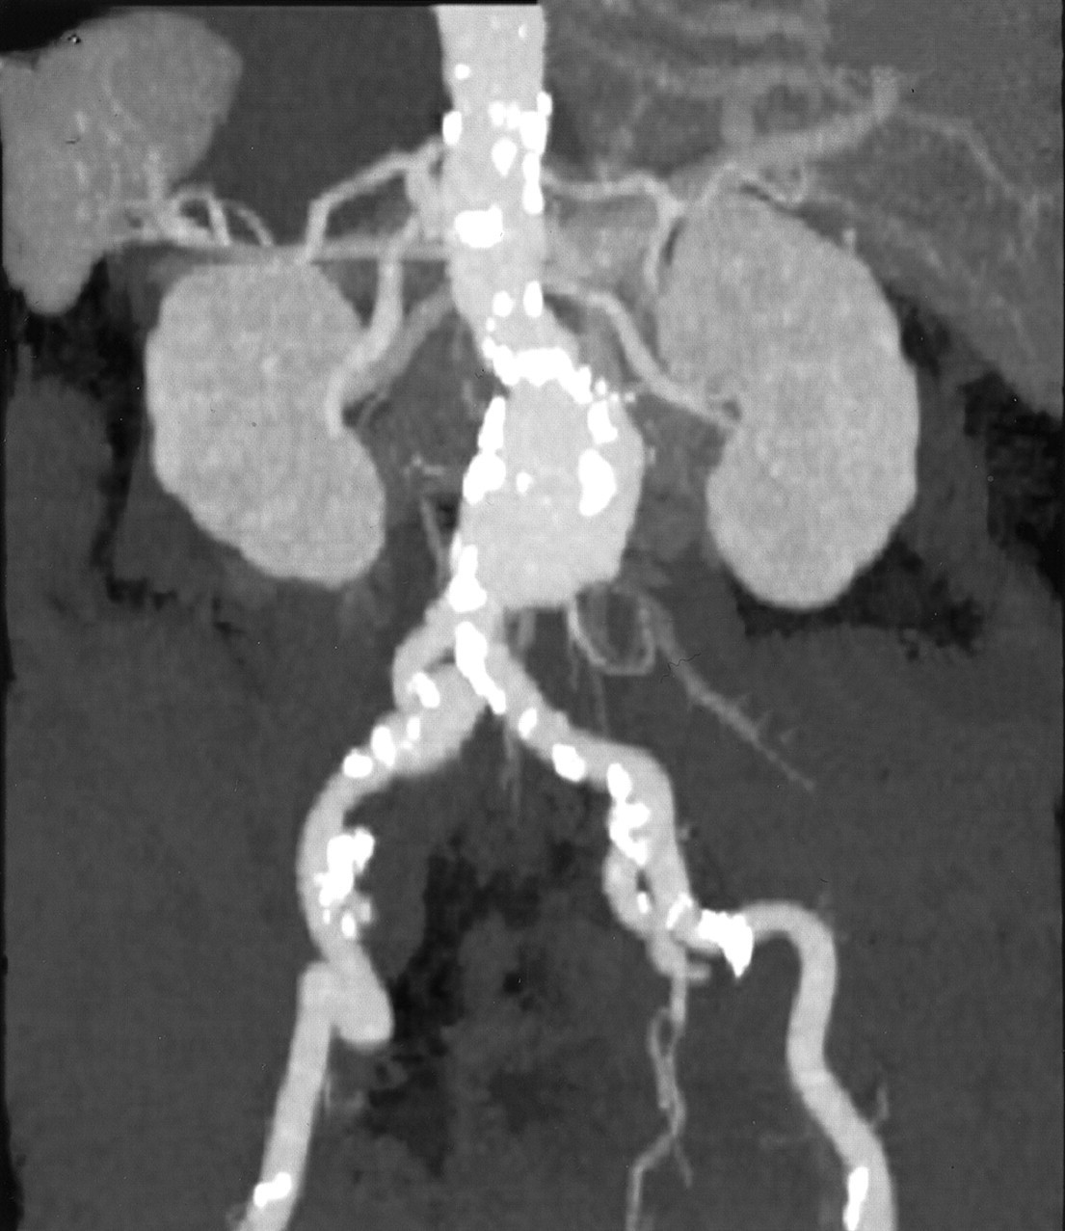
6.5 cm infrarenal AAA.
He is referred to your office for management. His medical history is significant for a 50 pack-year smoking history, diet-controlled diabetes, and hypertension on lisinopril.
He is vitally normal, and asymptomatic at this time aside from his lower GI bleed. His hemoglobin last week was 7.2.
Any Additional Workup or Studies:

- CTA to evaluate AAA anatomy:
Shows known 6.5 cm infrarenal AAA with 1.7cm infrarenal neck, 2cm neck diameter, 40° neck angle, 1cm femoral artery diameter.

What Would you like to do Now?
- EVAR candidate
- Pre-op optimization
  - Smoking cessation
  - Diabetes and BP control.
  - Monitor anemia and optimize with iron and vitamin supplements.
  - Pre-op type and screen
- EVAR FIRST, followed by left hemicolectomy in 2 weeks.

What is the risk of aneurysm rupture after laparotomy for non-vascular cause?

Increased may be due to activation of matrix metalloproteinases. Thus, aneurysm should be addressed.

Scenario: The patient is taken to the OR for EVAR, and on post op CT scan 1 week later demonstrates an asymptomatic type 2 endoleak from the IMA. How would you like to proceed?
- Proceed with colectomy.
- High ligation of the IMA which will resolve the endoleak.

Scenario: A similar patient presents to the ED with abdominal pain and is found to have an obstructing sigmoid mass and a concurrent 5.5 cm AAA. How would you proceed in this case?
- Urgent colectomy for resection of the mass and relief of the obstruction.
- Strongly consider colostomy or diverting loop ileostomy.
- Interval AAA repair either open retroperitoneal or EVAR approach.

This patient will need adjuvant chemotherapy, when should he get it in relation to timing of AAA repair?
After AAA repair to minimize risk of AAA rupture

Scenario: The same patient, with an obstructing sigmoid mass but now an 8cm AAA.
- Both the obstruction and the AAA should be dealt with urgently.
- Consider stenting the obstruction as a bridge to colectomy.
- AAA repair during this hospitalization
- CT chest abdomen and pelvis during this hospitalization for metastatic workup for colon cancer

Scenario: What if the patient had concomitant Renal Malignancy and AAA?
Combined procedure if risk of ATN/AKI low (not needing suprarenal clamp). Retroperitoneal approach to left kidney and aorta is appealing.

Can you combine AAA repair and GI procedure?
No, due to risk of graft infection.

Pitfalls: Understands timing of procedures.

References:
- Kawai K, Sunami E, Tanaka J, et al. Synchronous colorectal malignancy and abdominal aortic aneurysm treated with endovascular aneurysm repair followed by laparoscopic colectomy. Int Surg. 2015;100(4):600-603. doi:10.9738/INTSURG-D-14-00111.1
- DOI:https://doi.org/10.1016/j.jvs.2016.01.026

